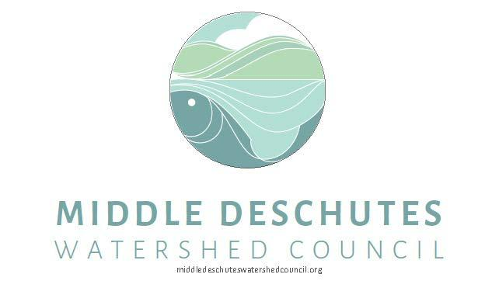

Job Description

Position: Environmental Education/Natural Resource Intern
Status: Part-Time, ~ 10 - 20 hours/week
Start Date: Negotiable: Approximately 09/25/2018
End Date: Negotiable: Approximately 06/30/2019
Compensation: $13.00/hour, mileage reimbursement, if applicable
Location: Central Oregon, Jefferson County

The Middle Deschutes Watershed Council is offering an internship opportunity. This opportunity is in partnership with the Children’s Forest of Central Oregon, Gray Family Foundation and the Jefferson County Soil and Water Conservation District.

Interns will gain educational value in a professional setting by playing an active role in developing and delivering the environmental education programing during the 2018 - 2019 school year to youth in the Middle Deschutes Watershed. Through this experience the intern will have opportunities to connect with partner organizations, assist with events, and network with community partners. The internship hours are flexible: 10-20 hours per week, with possible evenings and/or weekends as needed to achieve program goals.

Duties:
- Assist in planning, developing and delivering environmental education to K-12 students in participating classrooms and/or field locations in Jefferson County.
- Assist in coordinating program logistics with volunteers, partner organizations, and council staff.
- Provide general program support including in-classroom support, developing education materials and plans, creating and updating online educational content, organizing volunteers, collaborating with partners, general office duties, etc.
- Travel to and from project sites located in Redmond, Madras, and other areas.

Requirements:
- Interest in environmental education/conservation and previous experience working with students in preferably both indoor and outdoor settings.
- Excellent written and oral communication skills and a demonstrated ability to work independently with minimum supervision and to complete tasks on time as assigned.
- Ability to complete full internship period.
- Reliable transportation, valid driver’s license and insurance.
- Complete a background check.

Preferred Qualifications:
- OSU Cascades or Central Oregon Community College student or recent college graduate preferred ~ but will accept experience.
- At least one year of successful work/course experience in education, natural resources, community programs, and/or youth programs.
- Experience with delivering/providing education to students in some capacity.
- Demonstrated knowledge of local watersheds and watershed issues.
- Familiarity with web design or interest in learning web development skills.
- Preference will be given to students from Jefferson County, Oregon

Benefits:
The Middle Deschutes Watershed Council is pleased to offer this opportunity for the chosen applicant. This internship will be housed in the Redmond, OR office with frequent travel to Madras, OR and surrounding areas in Jefferson County. Direct supervision will occur through in-person meetings, email, and other methods, as appropriate. The intern will directly engage with professional educators, natural resource professionals, community members and partner organizations, in the planning and delivery of the education program.
The selected intern will also be offered the opportunity to earn academic credit through OSU-Cascades or Central Oregon Community College.
If interested, the intern can enroll in NR 410, a 3-credit academic internship in collaboration with the Natural Resource Program at OSU-Cascades. NR 410 requires an approved academic plan prior to the start of the internship and enrollment in NR410 during the internship. Or if applicable, the intern is eligible to receive 1 COCC course credit for ED 188: Environmental Education Internship.

Application Procedure:
To apply please submit a cover letter, resume, and three references to the Middle Deschutes Watershed Council by the application deadline of 09/21/2018. You can either mail the information to:

Middle Deschutes Watershed Council
625 SE Salmon Avenue #6
Redmond, OR 97756

Or submit by email to Debbe.Chadwick@oacd.org

If you have questions please contact me at 541-699-3170.

Job Type: Internship

